ASE INSEM LAB -1

Name: K Dheeran
Roll No: 2420090149
Date: 12/10/2026
Sec: 6
Set-5
Lab-Q5
Lab Task 1: Case Study and Process Model For a KL ERP System, identify suitable user stories, select an appropriate process model and programming language, and prepare a basic implementation plan.

Step One Open Trello and Login using your credentials
Step two Next Create Board ASE-INSEM Lab-1
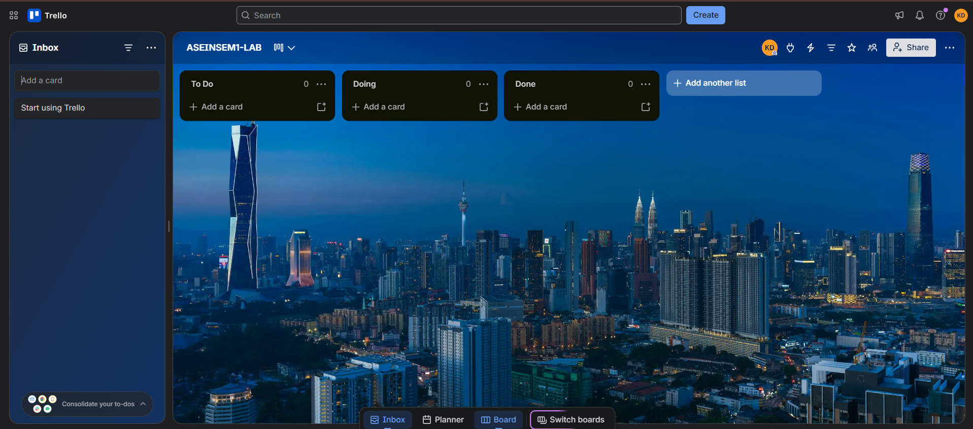
Step Three Add Product Backlog and Testing Lists
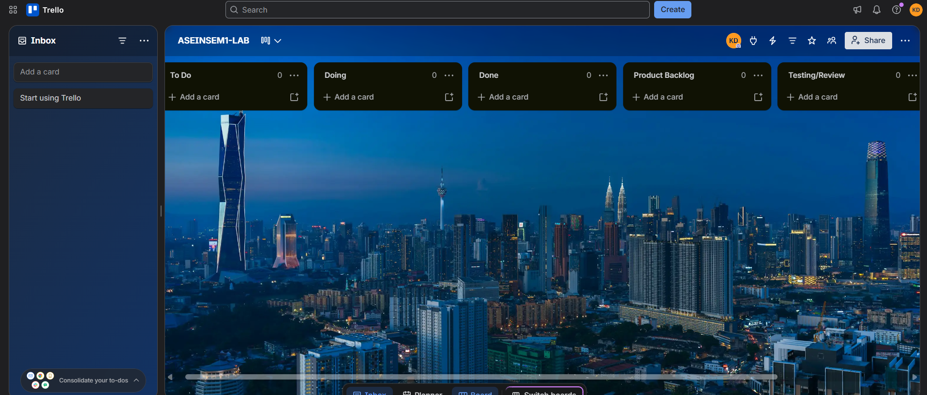
Step 4 In Product Backlog add 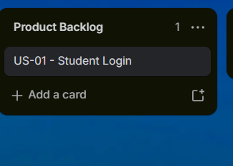
And its decription, 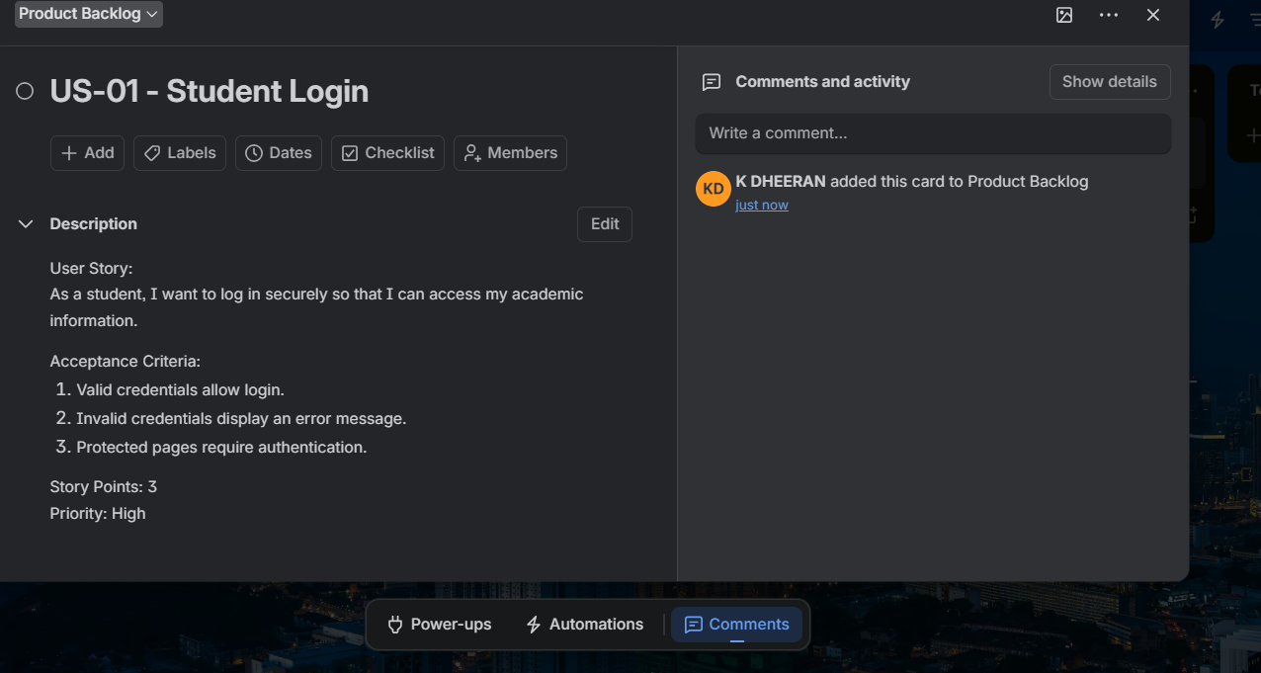
Course Registration
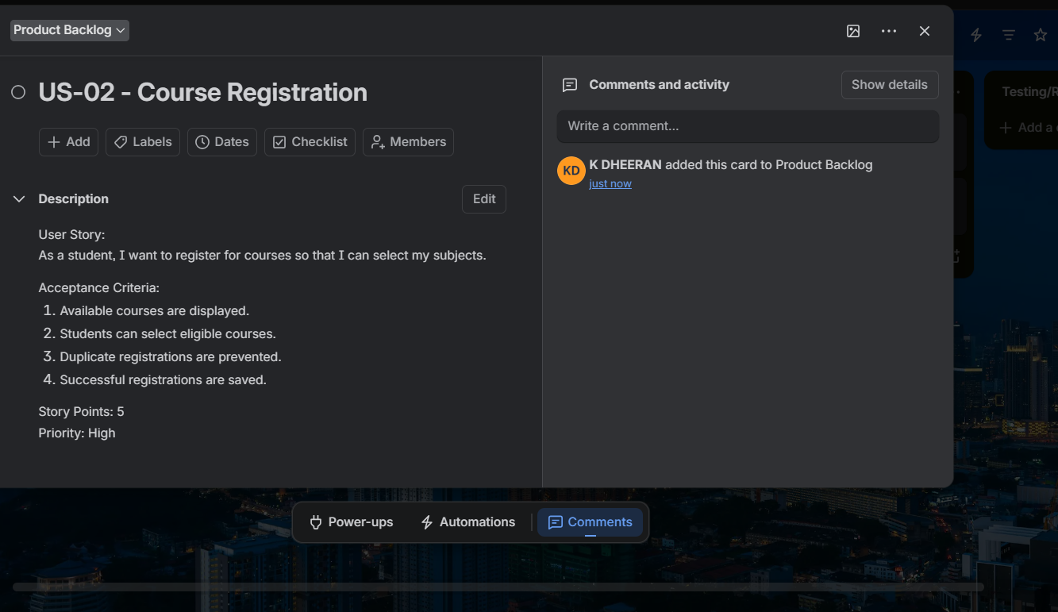
View Attendence
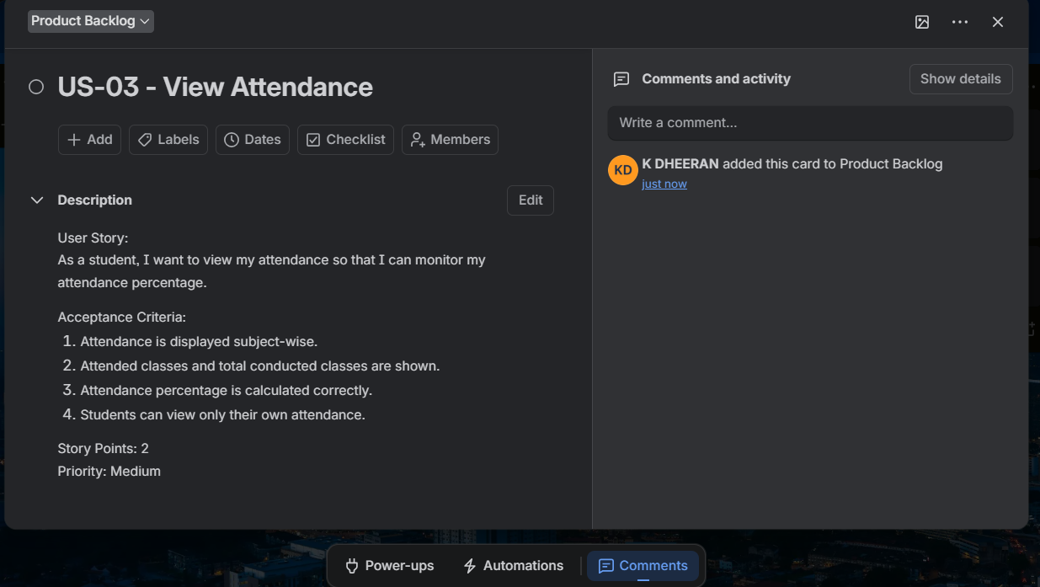
Faculty Marks
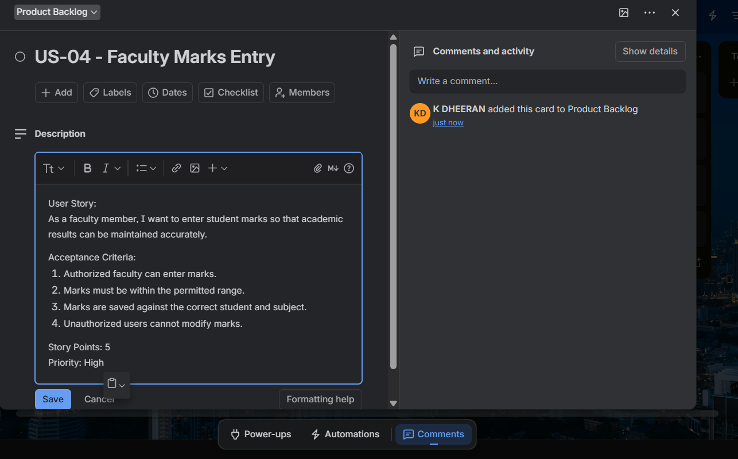

View Reuslts
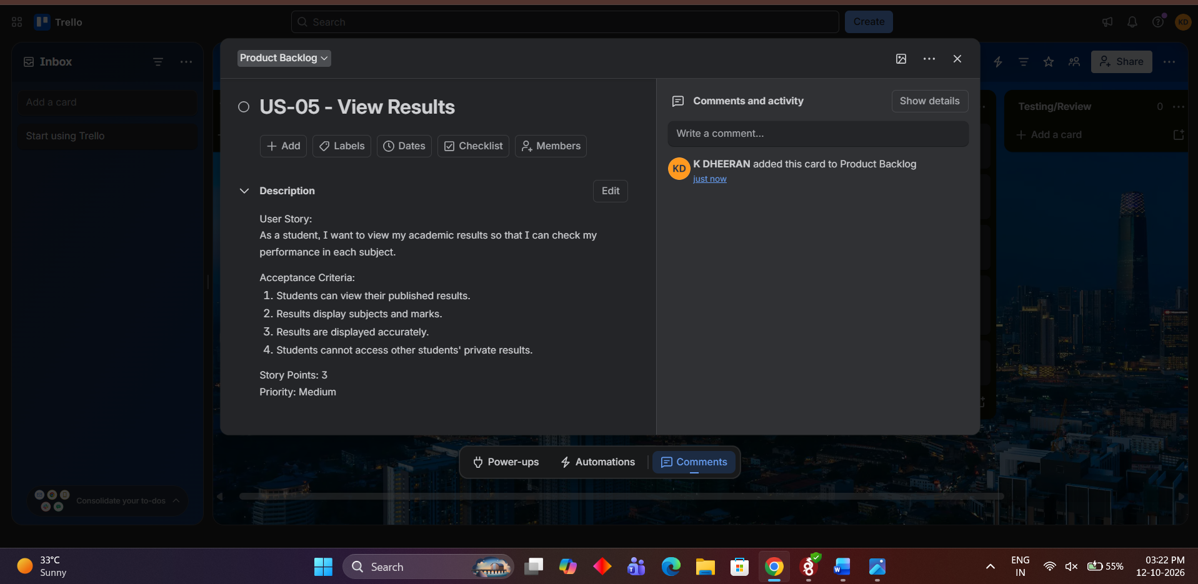
Step Five In To Do Add the cards
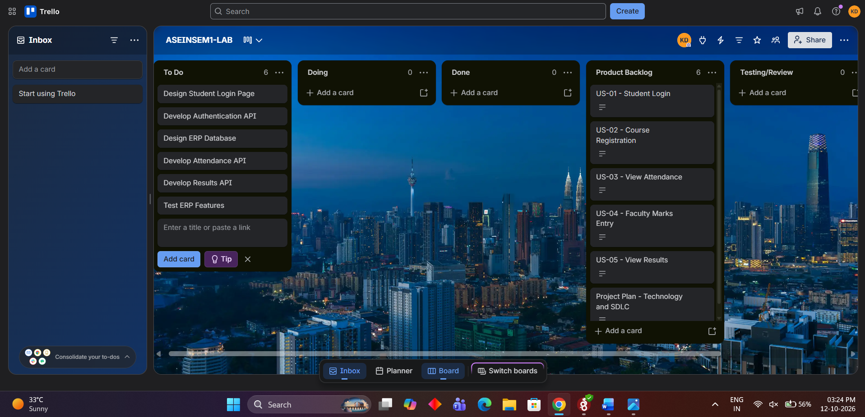
Move Cards from to -doo to doing
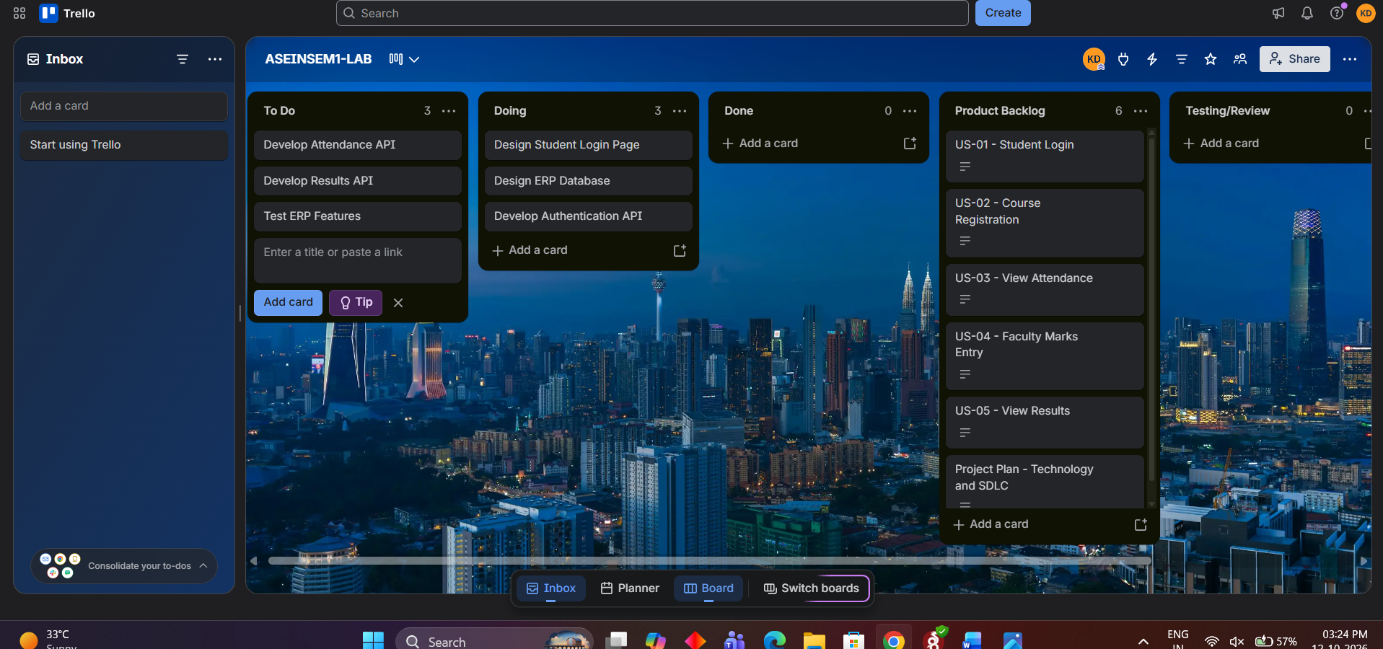
And from to doing to done
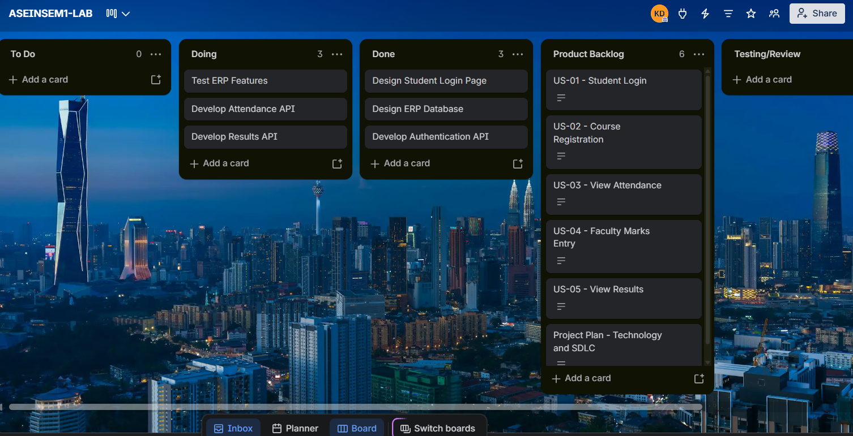
Step -Six Move from done to testing
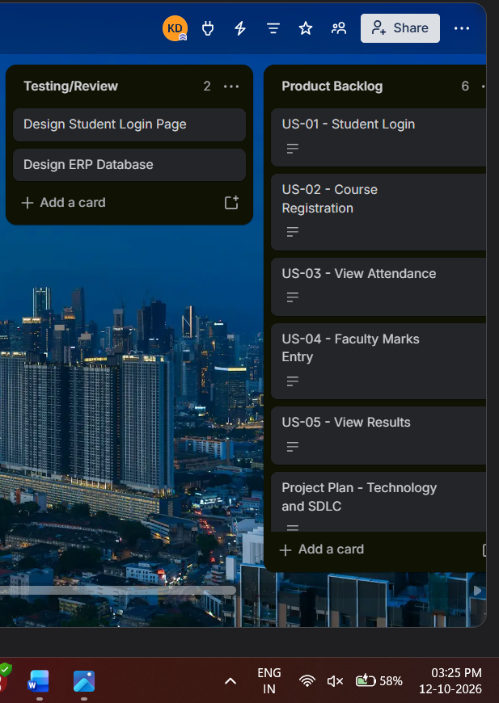
Step 7 Assign Due Dates and then assign people for the taks
Done.

